 | UU Small Group Ministry Institute 2013  Sponsored by the UU Small Group Ministry Network  and the Central East Regional Group, UUA
  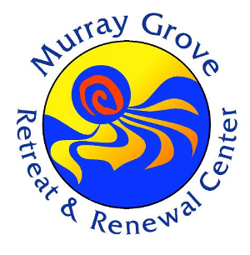 | 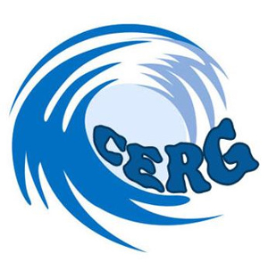
Monday, July 22 (3 pm) – Friday, July 26 (11:30 am)
Murray Grove Retreat and Renewal Center
Lanoka Harbor, NJ 08734 murraygrove@murraygrove.org

An Institute is a “working conference” designed for:
- Individuals & teams of adults and youth who attend as part of a congregation team.
- New and experienced program organizers, facilitators, ministers, religious educators, and other congregational leaders

As participants, you will:
- Learn about and practice Small Group Ministry through hands-on workshops, presentations, daily group sessions, worship, and networking
- Explore the impact of Small Group Ministry/Covenant Groups in congregations
- Build your facilitator skills, including problem resolution
- Create and select effective sessions, including the use of art, music, and movement
- Hone your capacity to build Small Group Ministry for specific audiences and congregational sizes
- Take home a plan for Small Group Ministry/Covenant Groups specific to your setting

HIGHLIGHTS OF THIS INSTITUTE:
- Individuals and congregations offer presentations on aspects of Small Group Ministry. See the Registration form to indicate your congregation’s interest.
- Focus on the expanding influence of Unitarian Universalist Small Group Ministry, including special ministries (Youth/Young Adult and Campus Ministry, Long Term Care and/or Elder Ministry, Religious Education with all ages, etc.)
- Open evening sessions with congregations in the area.
- Options are available for Commuters.

Cost: Lodging & Program Fee $400
Commuter rates are available. Monday and Friday, $35 each day; Tuesday –Thursday $70 each day
Additional Open Evening Sessions (Tuesday-Thursday): $30 Dinner and Program
$25 discount for registration before June 30, 2013 <><> $25 discount for UU SGM Network members
Online Conference Registration at https://www.formdesk.com/uuforms/SGMInstitute with credit card or copy and send with check.
More information will be sent when your registration is received.
THE INSTITUTE AS A WORKING CONFERENCE!

This institute brings a new level of Networking.
The focus is on contributions from participants. Each congregation has a story to share.
Each congregation is encouraged to contribute to the content of the Institute.
Bring a session plan, lead a discussion, present a new approach.

To note your contributions, complete the online form LINK and send to office@smallgroupministry.net
This is separate from the Institute Registration itself. We would like to have this as soon as possible, and definitely by June 15.

SMALL GROUP MINISTRY INSITUTUE 2013 July 22-26. 2013
DRAFT November 9, 2012

Time | Mon., July 22 | Tues, July 23 | Wed., July 24 | Thurs., July 25 | Fri., July 26
7:30 am  8:45 |  | Breakfasts  Greet the Day | Breakfasts  Greet the Day | Breakfasts  Greet the Day | Breakfasts  Greet the Day
9:00 |  | Impact of SGM on Your Congregation | The Place of SGM in Your Congregation | Taking SGM Beyond the Congregation | Other Items  Taking It Home
10:00-Noon |  | 1.New/Revitalization of SGM  2.Facilitator Training  3, SGM With All Ages | 1.New/Revitalization of SGM  2.Facilitator Training  3, SGM With All Ages | 1.New/Revitalization of SGM  2.Facilitator Training  3, SGM With All Ages | Closing SGM Sessions  11 Closing  11:30 Leave
12:30 pm | 3:00 Registration | Open time  SGM session  Staff Meeting | Open time  SGM session  Staff Meeting | Open time  SGM session  Staff Meeting
4:00 | Introductions | Meeting by congregational size | TBA  Resources | TBA  Resources
5:30  6:00  6:45 |  | Social Time  Dinner  Singing | Social Time  Dinner  Singing | Social Time  Dinner  Singing
7:00 | SGM Session: Review, session  Process | Best Practices: what works and why, all sizes of congregation | Meetings for  --Ministers  --Religious Educ.  --Lay SGM leaders | SGM as Congregational Outreach/Service
9:00 | Social Time | Social Time | Social Time | Social Time

Notes:
- Evening Programs Tuesday-Thursday will be open to congregations in the area, with registration, and will include congregations in presentations.
- There will be SGM sessions each day with groups of 5-8, with opportunity to rotate facilitation.
Participants attending for less than the full Institute will be included in an “Open Group”
- Groups will share set-up and clean-up for meals as part of service.

WATCH THE WEBSITE AND OTHER COMMUNICATIONS FOR EVOLVING PLANS!
REGISTRATION FOR UU SMALL GROUP MINISTRY INSTITUTE 2013
SAMPLE ONLY

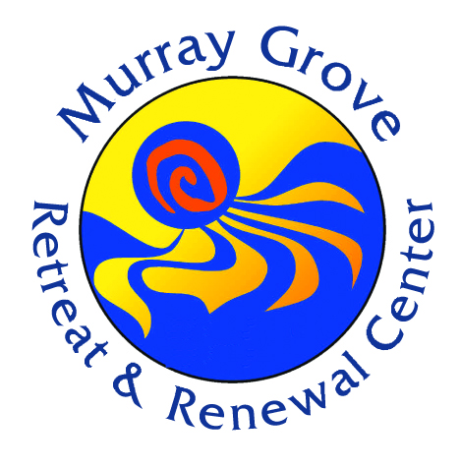 | Online Conference Registration ONLY at https://www.formdesk.com/uuforms/SGMInstitute  Use credit card or print the online form and send with check to address on the registration form
YOUR NAME |  | E-MAIL ADDRESS AND/OR PHONE |  | GEN-DER
EMERGENCY CONTACT: NAME |  | EMERGENCY PHONE NUMBER |  | UNDER 18 YRS.
CONGREGATION NAME_____________________________________________________________
City: ____________________________________________________________ ST _
Your Role: SGM group member____ Group Leader_____ SGM Coordinator_____
Congregational leader____ Minister_____ Other, Specify

CATEGORY | ADDITIONAL DETAILS | $ Enter
Full Institute, | Staying at Murray Grove $400 ___ Commuting $270_____ | $
Part time Commuter, specify | Monday (3-9pm) $35 ___ Tuesday (7:30am-9pm) $70 ___ Wednesday (7:30am-9pm) $70___ Thursday 7:30-9pm) $70___  Friday (7:30-11:30am $35__ | $
Evening Programs ONLY: Dinner and Program | Tuesday $30__ Wednesday $30__ Thursday $30___ | $
Membership Status:  Congregational member___  Individual member ____ | Membership with this registration allows discount. Congregational membership allows discount for multiple registrations.  Membership: Congregational $100 ___ Individual $40 ____ | $
 | SUBTOTAL | $
Discounts: | Early Registration by June 30 $25___ Network Membership $25____ | -$
 | TOTAL DUE | $
Payment Information: Make check payable to UU SGMN. Mark “Institute” under memo.
Cancellation Policy: For cancellation received by e-mail or in writing prior by July 1, 2013, amount paid less a $25 per registration administrative fee will be refunded. Cancellations between July 1-15 will receive a refund of fees paid less a $50 administrative fee per registration. Refund may not be possible after July 15.

Housing Considerations: Double occupancy. Housing assigned on a first come/first-served basis except for mobility needs. If you do not indicate a roommate preference, other registrants will be assigned as roommates.
Roommate preference ______________
Snores______ Bothered by snoring________ Other considerations, specify:
Mobility Considerations, specify: ______
Food Preferences: Regular Diet_____ Vegetarian ____ Vegan ____ Allergies ____________
Other (Please explain) _____
Morning (10-noon, Tues-Thurs): Indicate preference, with 1 as first choice:
New/Revitalization of SGM___ Facilitator Training_____ SGM With All Ages_____

You will receive confirmation of receipt of your registration and additional information about the Institute.

