Unitarian Universalist Small Group Ministry Network Website
Dreaming a Year
Unitarian Universalist Fellowship of Stony Brook, NY, January 2013
Rev. Margie Allen and Rev. Dr. Linda Anderson

[Facilitators: Ask group members to bring a recent picture of themselves (that can be sacrificed for a project) and a quotation that they are finding particularly meaningful right now in their lives. You will need to secure the box of supplies prior to your meeting time. Try to preserve at least 45 minutes for the crafting of the dream boards. This might mean limiting the check-in sharing time just for this session. Letting each person choose a quote to include on their board might preserve some time as well.]

Opening Words To the New Year (W. S. Merwin)

With what stillness at last
you appear in the valley
your first sunlight reaching down
to touch the tips of a few
high leaves that do not stir
as though they had not noticed
and did not know you at all
then the voice of a dove calls
from far away in itself
to the hush of the morning

so this is the sound of you
here and now whether or not
anyone hears it this is
where we have come with our age
our knowledge such as it is
and our hopes such as they are
invisible before us
untouched and still possible
To the New Year
With what stillness at last
you appear in the valley
your first sunlight reaching down
to touch the tips of a few
high leaves that do not stir
as though they had not noticed
and did not know you at all
then the voice of a dove calls
from far away in itself
to the hush of the morning

so this is the sound of you
here and now whether or not
anyone hears it this is
where we have come with our age
our knowledge such as it is
and our hopes such as they are
invisible before us
untouched and still possible

Chalice Lighting and Silence

[Covenant Review]

Check-in (Suggested focus: Share a highlight of your 2013 New Year’s holiday experience).

Topic Introduction
This is the time of year, the head of the calendar year, when people traditionally try to articulate their goals and resolutions for the year ahead. From the threshold of New Year’s Day we look at the journey through the twelve months and four seasons ahead and imagine the big and small accomplishments we’d like to celebrate next December. Our session today introduces a powerful tool for making that process more real and imaginative, more fun and compelling. Today we will each have the opportunity to create a dream collage for 2013: a collage of images, pictures and affirmations of your dreams and desires.

Each person will be given a half-poster board to cover with a collage of photos, magazine clippings, drawings, words and anything else that you choose to use to tell the story of the 2013 you’d like to experience. Making the collage helps you focus on purpose and direction in your life this year. As you talk about your dream collage in the circle tonight you might see aspects of your collage that you did not plan, messages that emerge as products of your intuition, your aesthetic values or just by chance. The collages other people create may offer you other ideas and inspiration. Looking at your collage daily at home will keep you in touch with your goals and continue to inspire, motivate and encourage you to keep moving towards their manifestation.

Quotations

Activity
[Facilitators: The supply box contains half-poster boards, scissors and glue for each person in the group as well as a dream board sample sheet, some additional magazines, some markers and colored pencils for drawing and writing on the posters and a sheet of newsprint for each group. You will supply the magazines and other material (newspapers, old calendars, catalogs, for instance) from which group members will harvest words and pictures for their dream boards. You might want to write the “Step Two” points on the newsprint and post it where everyone can see. Encourage the group to keep a meditative quiet in the room while they are working on their boards.]

Step One: Dream (a writing meditation)
Settle your group members to write a bit about their dreams for the year to come. Suggest they make a list of all their dreams—both big and small. What do you want to do? Where do you want to go? What do you want to study or explore or find? What do you want to look like or feel? Who do you want to spend time with? How do you want to serve your communities or the world? List anything and everything that comes to mind.

Step Two: Make your Dream Collage
- The list you made during the meditation is not a prescription for your collage. It was only a starting place. Be open to spontaneous inspiration.
- You might want to start with a background (or not).
- You can title the board if you want to.
- It might help to start by cutting out most of your pictures and words (or not)
- You can use your photo and quote, words and pictures cut out of magazines and you can also write or draw.
- Don’t think too much. You don’t have to fill every space. This is not about artistic skill. It is about creating a clear message to yourself that will continue to inspire you all year.
- If you come across an image or word you want to use, but don’t know why—put it in.
- Bright colors are good. You want your eye to be drawn to the collage every day.
- You can concentrate on one dream theme or include them all or anything in between.

Questions for Group Reflection
- Briefly describe your dream board to the group.
- What did you learn about yourself as you made and now as you look at your dream collage? Does anything about it surprise you?
- Were there any difficult decisions you had to make as you were in the creative process?
- Do you see any patterns in your own collage that you were not aware of during the creative process (relationships between images, distribution of colors, resonance in words, for instance)?
- Imagine your 2013 unfolding such that the dreams you named in your collage really did all manifest! Are you ready for that to happen?
- Do you see any patterns or details in someone else’s collage that they did not mention that you would like to point out? (Ask the person’s permission before you comment on their work.)
- What do your dream boards, taken together, say about your Sharing Circle?

Likes and Wishes

Closing Words and Chalice Extinguishing

Dreams (Langston Hughes)
Hold fast to dreams
For if dreams die
Life is a broken-winged bird
That cannot fly.
Hold fast to dreams
For when dreams go
Life is a barren field
Frozen with snow.

Quotations

I can teach anybody how to get what they want out of life. The problem is that I can't find anybody who can tell me what they want. ~Mark Twain

If one advances confidently in the direction of his dreams, and endeavors to live the life which he has imagined, he will meet with success unexpected in common hours.
~Henry David Thoreau

Vision is the art of seeing the invisible. ~Jonathan Swift
It is very dangerous to go into eternity with possibilities which one has oneself prevented from becoming realities. A possibility is a hint from God. One must follow it.
~Sören Kierkegaard

Keep your eyes on the stars and your feet on the ground. ~Franklin D. Roosevelt
Looking up gives light, although at first it makes you dizzy. ~Rumi

You cannot depend on your eyes when your imagination is out of focus. ~Mark Twain

You've got to think about big things while you're doing small things, so that all the small things go in the right direction. ~Alvin Toffler

The greatest danger for most of us is not that our aim is too high and we miss it, but that it is too low and we reach it. ~Michelangelo

In order to be a realist you must believe in miracles. ~David Ben-Gurion

Dreams are the touchstones of our character. ~Henry David Thoreau

Without leaps of imagination, or dreaming, we lose the excitement of possibilities. Dreaming, after all, is a form of planning. ~Gloria Steinem

Throw your dreams into space like a kite, and you do not know what it will bring back: a new life, a new friend, a new love, a new country. ~Anais Nin

When all your desires are distilled / You will cast just two votes: / To love more, And be happy. ~Hafiz of Persia

Let go of the past and go for the future. Go confidently in the direction of your dreams. Live the life you imagined. ~Henry David Thoreau

Your vision will become clear only when you look into your heart. Who looks outside, dreams. Who looks inside, awakens. ~Carl Jung


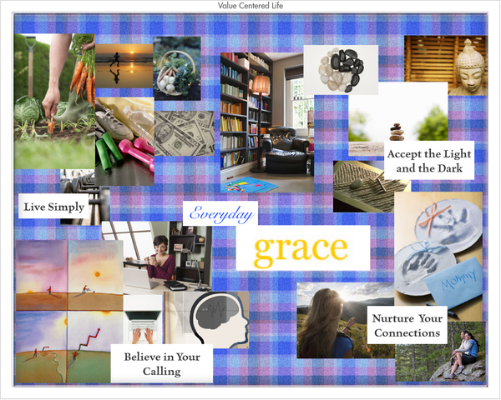
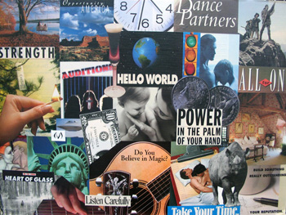


Samples of Dream Boards

