Small Groups for Children
A Covenant
From Kathy Cronin, Director of Lifespan Religious Education
Eno River Unitarian Universalist Fellowship, Durham, NC
Small Group Ministry Journal, Fall 2012/Winter 2013

Method: On a easel pad, draw a large person with the stated body parts. Explain the promises using the picture as a guide. Review weekly. Eventually the children will be able to remember the promises themselves.

Head: Open your mind to exploring things you do not know or people you do not know.

Eyes: Make eye contact with others when they speak and when you speak.
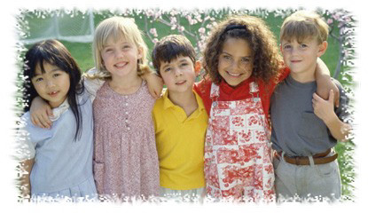
Ears: Listen when others are speaking.

Lips: One person speaks at a time.
Talk about what you think and feel.
Ask for what you need.

Heart: Open your heart and be kind, treat others as you would like to be treated.

Hands: Offer a helping hand when someone asks for your help.

Legs: Try to understand what a person is saying by walking in that person’s shoes.

-Taken from the Small Group Ministry Network Journal, Fall 2012

